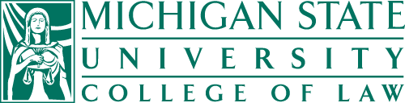

SUMMER SCHOOL ON COMPARATIVE EU-US LAW
Faculty of Law, University of Bialystok &
Institute for Comparative Law & Jurisprudence at the Michigan State University College of Law

24 May – 19 June 2020

REGISTRATION FORM

- Name and last name:

- Year of study:

- Student ID #:

- Address:

- Telephone #:

- Email address:

- Short description why you would like to participate in the program (max 250 words) :
………………………………………………………………………………………………………………………………………………………………………………………………………………………………………………………………………………………………………………………………………………………………………………

Białystok, date. …………………..

